|  |  |  |  |  |  |  |  |
| --- | --- | --- | --- | --- | --- | --- | --- |
| **1** | |  | **INTRODUCTION** | |  |  |  |
|  | |  | 1.1 Overview | |  |  |  |
|  | |  | 1.2 Purpose | |  |  |  |
| **2** | |  | **LITERATURE SURVEY** | |  |  |  |
|  | |  | 2.1 Existing problem | | |  |  |
|  | |  | 2.2 Proposed solution | | |  |  |
| **3** | |  | **THEORITICAL ANALYSIS** | |  |  |  |
|  | |  | 3.1 Block diagram | |  |  |  |
|  | |  | 3.2 Hardware / Software designing | | |  |  |
| **4** | |  | **EXPERIMENTAL INVESTIGATIONS** | | |  |  |
| **5** | |  | **FLOWCHART** | |  |  |  |
| **6** | |  | **RESULT** |  |  |  |  |
| **7** | |  | **ADVANTAGES & DISADVANTAGES** | | |  |  |
| **8** | |  | **APPLICATIONS** | |  |  |  |
| **9** | |  | **CONCLUSION** | |  |  |  |
| **10** | |  | **FUTURE SCOPE** | | **`** |  |  |
| **11** | |  | **BIBILOGRAPHY** | |  |  |  |
|  | |  | **APPENDIX** | |  |  |  |
|  |  | | A. Source code | |  |  |  |
|  |  | |  |  |  |  |  |

1. **INTRODUCTION**

In this project, I am building a chatbot using Watson assistant. This chat bot should have the following capabilities:

* Give the list of movies available
* The Bot should be able to show different show timings
* When a movie is selected the bot should show the availability of tickets and their respective prices.
* The bot should be in a position to book tickets.

* 1. **Overview**

A chatbot is an artificial intelligence [(AI) software that can simulate a conversation](https://expertsystem.com/learning-center/technology/) (or a chat) with a user in natural language through messaging applications, websites, mobile apps or through the telephone.A chat bot is often described as one of the most advanced and promising expressions of interaction between humans and machines. However, from a technological point of view, a chatbot only represents the natural evolution of a Question Answering system leveraging Natural Language Processing (NLP). Formulating responses to questions in natural language is one of the most typical Examples of Natural Language Processing applied in various enterprises’ end-use applications.

* 1. **Purpose**

A user can enter a query in text format. The query is then sent to the AIML Corpus via Chatbot System. The Template for query is searched in AIML Corpus. If Template matching is found then it is sent as are a response in both text format. But if Template matching to query is found then a default message is displayed.

1. **LITERATURE SURVEY**

**2.1Existing problem**

A Chatbot is system implemented by many researcher to support various types of platforms. Most of them are customized for particular platform. We have examined two systems based on this technology:- Paper1: Title of Existing System or Paper: Odeon’s Chatbot for Movie Ticket Booking Odeon’s chatbot, developed by social technology company Gruvi, requires user to like the brand’s Facebook page and then either click “Message” or type “Odeon” into a chat search. The bot then informs the customer of nearby cinemas or where, and what time, their selected film is showing. Once a decision has been made, the customer is sent a link to a booking page. Paper2: Title of Existing System or Paper: Design of Chatbot with 3D Avatar, Voice Interface, and Facial Expression. This paper specifies chatbot that respond in 3D avatar, voice detection, face expressions, gestures. Distinguish the voice with too many unneeded noise. Paper 3: An Internet Relay Chatbot Using AIML: A chatterbot (also known as a talkbot, chatbot, "Bot”, chatterbox, Artificial Conversational Entity or similar) is a computer program which conducts a conversation via auditory or textual methods. Paper 4: Smart Answering Chatbot based on OCR and over generating Transformations and Ranking. Paper 5: Chatbot Using a Knowledge in Database. Paper 6: An intelligent web-based voice chatbot.

**2.2.Proposed solution**

The proposed system is BookMyShow, was founded by Hemrajani, Parikshit c Dar and Rajesh Balpande. In 2007 they officially came up with BookMyShow website. The major purpose of this startup was to bring the concept online movie ticket in India. And soon as it expanded, it started offering online ticketing solution for the theaters, events, concerts and sports. Existing system first came a TRADITIONAL WAY of booking ticket i.e. ’WINDOW’ booking. Then came a SMART APPLICATION to book ticket i.e. BOOK MY SHOW .Now we can also book a ticket by AUTOMATED WAY i.e. CHATBOT.

1. **THEORITICAL ANALYSIS**
   1. **Block diagram**

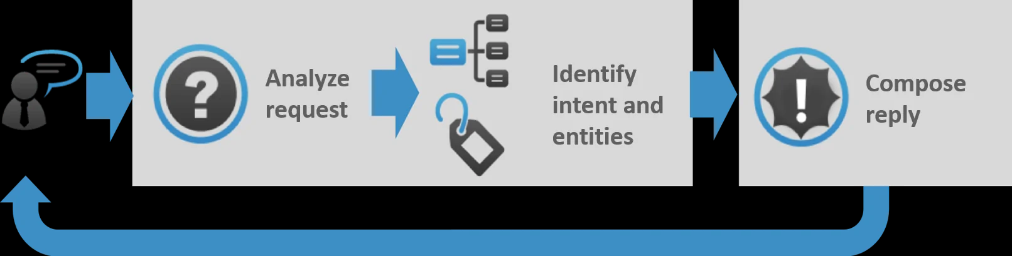

* 1. **Hardware / Software designing**

|  |  |  |
| --- | --- | --- |
| **Sr. No.** | **Query Type** | **Chatbot** |
| 1 | Memory requirement (In KB) | 1700 kb  (No DB Storage) |
| 2 | No. of steps executed to book a movie | Depending upon query input  (All the booking process can be executed in one step) |
| 3 | Ease of use | Yes |
| 4 | Database requirement | YES |
| 5 | Accuracy of the response generated | yes |
| 6 | Software’s need to be installed | IBM Watson assistant, Node RED app |
| 7 | Installation | Can be added as an plugin or messenger friend to chat with. |

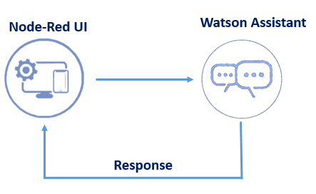

1. **EXPERIMENTAL INVESTIGATIONS**

* **While doing this project i followed the following paper** Chatbot Implementation for Movie Booking Using NLP.

1. **FLOWCHART**

Semantic Analysis

Patteren match the keywords

Extract the answer

Establish the AIML corpus

Feedback the result

Receives the User input

1. **RESULT**

In Watson Assistant if we give hi bot will respond with movies list.

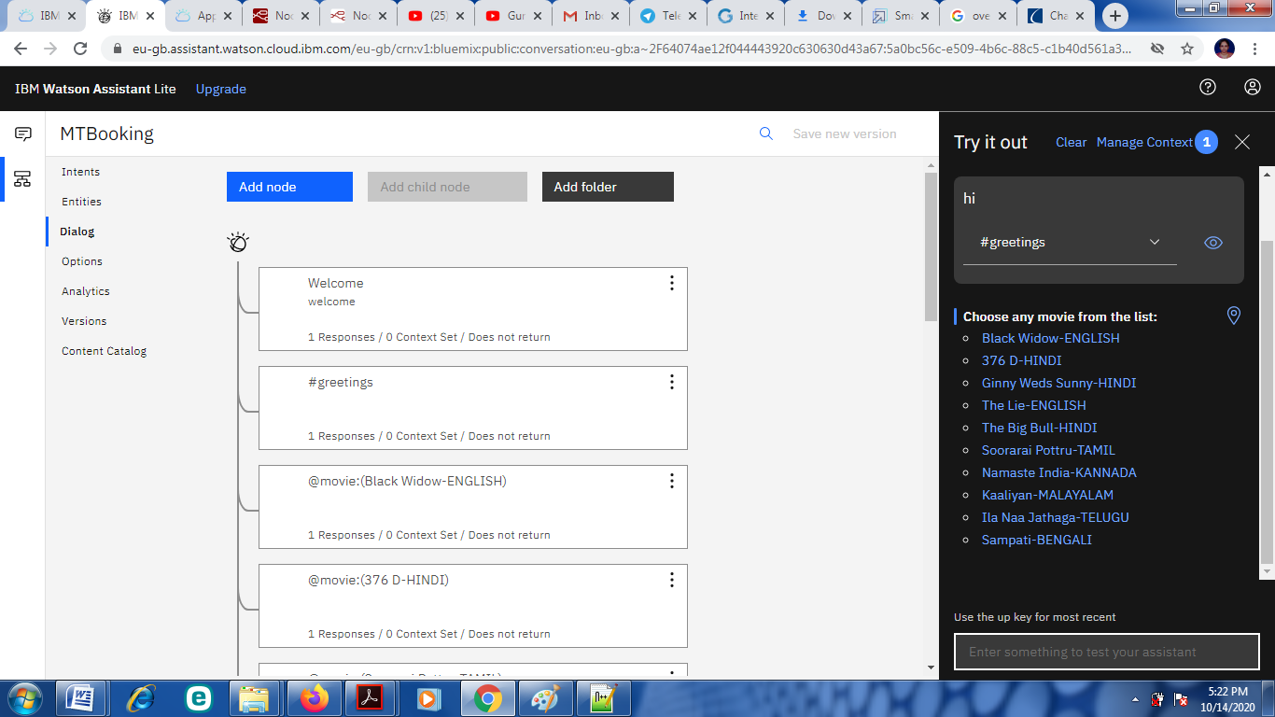

Then we select the movie it will respond with the movie poster with location where you want to book the tickets

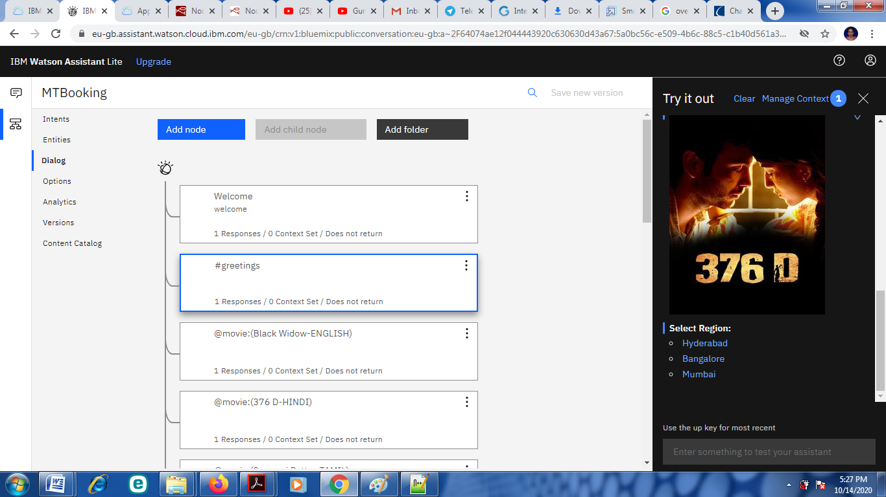

Then select the region bot will ask for the number of seats how many you want to book then on which date.

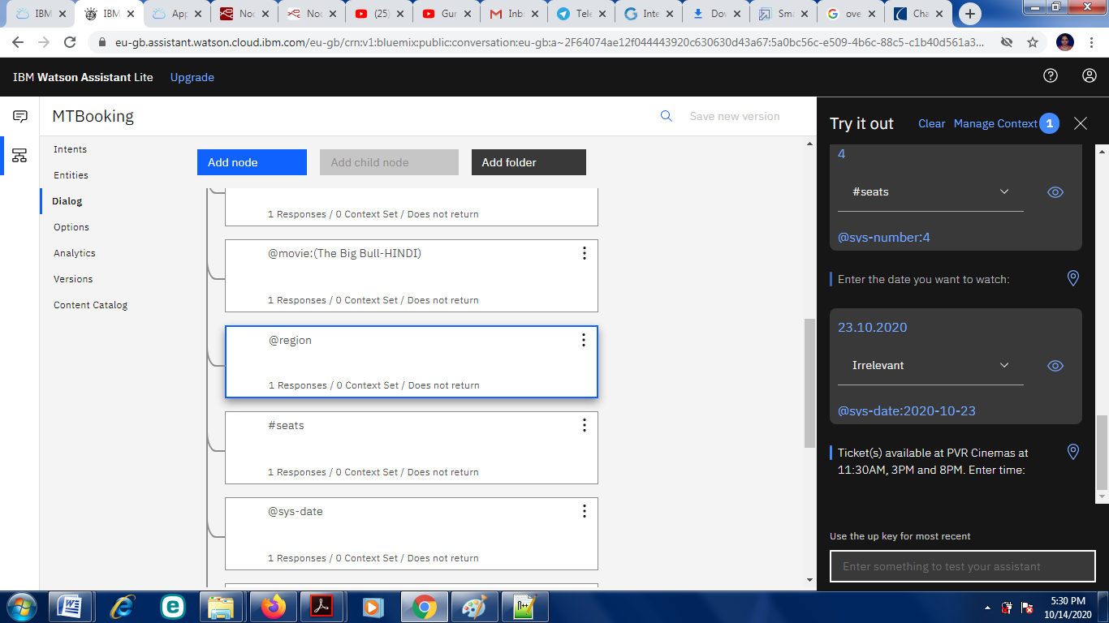

Bot will respond with the show is available in which location at what time you want to watch the movie. We have to give time then it will ask our mobile number to send OTP then we have to enter otp. Bot will send the booking details to mobile number.

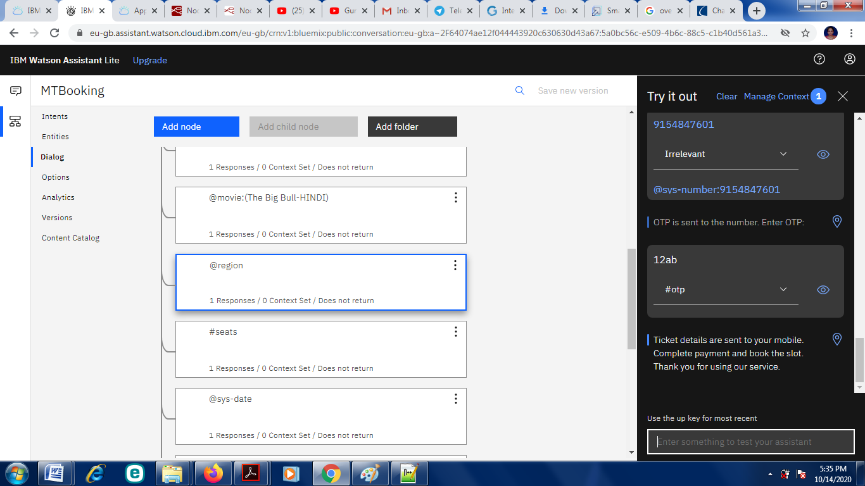

1. **ADVANTAGES & DISADVANTAGES**

* **Advantages**
* Bots are a lot easier to install than mobile apps and they can save users the much needed storage space on their smart phones.
* Mobile app can be expensive to build, maintain, and display.
* Messaging apps are already dominating engagement so no need to start your efforts from the scratch.
* Bots interact with customers in natural conversational language.
* Context Awareness
* Free of cost.
* **Drawbacks:**
* Lack of Emotions
* Difficult to Create
* Made to Handle First-Level Questions
* Require Maintenance

1. **APPLICATIONS**

#### E-Commerce

#### Travel

#### Finance

#### Hospitality

#### Healthcare

#### Insurance

#### Media

#### Real estate

1. **CONCLUSION**

Movie Ticketing Chatbot in apps are basically an upgrade to a mobile user interface, as they bring the most basic type of human interaction into the digital environment. A simpler, faster and more intuitive user interface results in an overall better user experience, which is one of the key factors for mobile growth. The future scope is limitless. First there was traditional ticket booking i.e. Window Booking then came a Smart Application i.e. BOOK MY SHOW now came an Automated Way i.e. CHATBOT. This movie ticket booking chatbot gives exact time date and location of movie the user wants to watch.

**10.FUTURE SCOPE**

The future of chatbots is that businesses will automate simple payments and allow users to pay directly over live chat or Facebook Messenger apps. The instant process makes the customer happy and improves customer satisfaction.MasterCard has also launched a chatbot, especially for customer payments. These capabilities of the bots to answer queries related to account balance, assist customers to set payment alerts and collect final payments from customers.

**10.BIBILOGRAPHY**

1. Chatbot Evaluation and Database Expansion via Crowdsourcing, Author: Zhou Yu, Ziyu Xu, Alan WBlack, Alexander I. Rudnicky, and May 12, 2017.
2. Chatbot Using A Knowledge in Database, Authors: Bayu setiaji, Ferry Wahyu Wibowo, Jan. 2016.
3. A model of social chatbot, Author: Manuel Gentile, Lucas Weideveld, Frank Dignum, June 2016.
4. Smart Answering Chatbot based on OCR and over generating Transformations and Ranking, Authors: Ly Pichponreay, Chi-Hwan Choi, Jin-Hyuk Kim, Kyung-Hee Lee, Wan-Sup Cho, and July 2016.
5. Design of Chatbot with 3D Avatar, Voice, Interface, and Facial Expression, Authors: Antonius Angga, P, Edwin, Fachri W, Elevanita A, Suryadi, Dewi Agushinta R, Oct. 2015.
6. An Internet Relay Chat Bot Using AIML, Authors: Om Kumawar Prasad, Thakar Rohit Shetty Akshay Bartukke, Volume 4 Issue 10, October 2015.
7. Using dialogue corpora to train a chatbot, Author: Bayan Abu Shawar and Eric Atwell, May 2015.
8. Chinese Intelligent Chat Robot Based on the AIML Language, Authors:-Ma Pei Zi, SunBo, and Sun Ming Chen, Wei Yun Gang, and Zhao Cui Yi Dept. of Computer. Sci. & Technol., Beijing Normal Univ. (BNU), Beijing, China, Aug, 2014.

**Youtube Links:**

1. <https://www.youtube.com/watch?v=zVfp8FayCo0>
2. https://www.youtube.com/watch?v=mWZLuHpcZRY
3. https://www.youtube.com/watch?v=Jn63jE-XK1E

**APPENDIX**

* 1. **Source code**

{

"intents": [

{

"intent": "greetings",

"examples": [

{

"text": "Hello"

},

{

"text": "Hi"

},

{

"text": "Ok"

},

{

"text": "Okay"

}

],

"description": ""

},

{

"intent": "otp",

"examples": [

{

"text": "12AB"

}

],

"description": ""

},

{

"intent": "seats",

"examples": [

{

"text": "1"

},

{

"text": "2"

},

{

"text": "3"

},

{

"text": "4"

},

{

"text": "5"

},

{

"text": "6"

}

],

"description": ""

},

{

"intent": "thankyou",

"examples": [

{

"text": "Thanks"

},

{

"text": "Thank you"

}

],

"description": ""

},

{

"intent": "time",

"examples": [

{

"text": "11:30AM"

},

{

"text": "11:30 AM"

},

{

"text": "3PM"

},

{

"text": "3 PM"

},

{

"text": "8PM"

},

{

"text": "8 PM"

}

],

"description": ""

}

],

"entities": [

{

"entity": "movie",

"values": [

{

"type": "synonyms",

"value": "376 D-HINDI",

"synonyms": []

},

{

"type": "synonyms",

"value": "Black Widow-ENGLISH",

"synonyms": []

},

{

"type": "synonyms",

"value": "Ginny Weds Sunny-HINDI",

"synonyms": []

},

{

"type": "synonyms",

"value": "Ila Naa Jathaga-TELUGU",

"synonyms": []

},

{

"type": "synonyms",

"value": "Kaaliyan-MALAYALAM",

"synonyms": []

},

{

"type": "synonyms",

"value": "Namaste India-KANNADA",

"synonyms": []

},

{

"type": "synonyms",

"value": "Sampati-BENGALI",

"synonyms": []

},

{

"type": "synonyms",

"value": "Soorarai Pottru-TAMIL",

"synonyms": []

},

{

"type": "synonyms",

"value": "The Big Bull-HINDI",

"synonyms": []

},

{

"type": "synonyms",

"value": "The Lie-ENGLISH",

"synonyms": []

}

],

"fuzzy_match": true

},

{

"entity": "region",

"values": [

{

"type": "synonyms",

"value": "Bangalore",

"synonyms": []

},

{

"type": "synonyms",

"value": "Hyderabad",

"synonyms": []

},

{

"type": "synonyms",

"value": "Mumbai",

"synonyms": []

}

],

"fuzzy_match": true

},

{

"entity": "sys-date",

"values": [],

"fuzzy_match": true

},

{

"entity": "sys-number",

"values": [],

"fuzzy_match": true

}

],

"metadata": {

"api_version": {

"major_version": "v2",

"minor_version": "2018-11-08"

}

},

"dialog_nodes": [

{

"type": "standard",

"title": "Anything else",

"output": {

"generic": [

{

"values": [

{

"text": "I didn't understand. You can try rephrasing."

},

{

"text": "Can you reword your statement? I'm not understanding."

},

{

"text": "I didn't get your meaning."

}

],

"response_type": "text",

"selection_policy": "sequential"

}

]

},

"conditions": "anything_else",

"dialog_node": "Anything else",

"previous_sibling": "node_3_1602051074676",

"disambiguation_opt_out": true

},

{

"type": "standard",

"output": {

"generic": [

{

"values": [

{

"text": "Enter the date you want to watch:"

}

],

"response_type": "text",

"selection_policy": "sequential"

}

]

},

"conditions": "#seats",

"dialog_node": "node_2_1602050554341",

"previous_sibling": "node_5_1602050341114"

},

{

"type": "standard",

"output": {

"generic": [

{

"source": "https://encrypted-tbn0.gstatic.com/images?q=tbn%3AANd9GcSzUlbodCsvfdaX3Yeq6HffABHsMlbOUrRsPg&usqp=CAU",

"response_type": "image"

},

{

"title": "Select Region:",

"options": [

{

"label": "Hyderabad",

"value": {

"input": {

"text": "Hyderabad"

}

}

},

{

"label": "Bangalore",

"value": {

"input": {

"text": "Bangalore"

}

}

},

{

"label": "Mumbai",

"value": {

"input": {

"text": "Mumbai"

}

}

}

],

"response_type": "option"

}

]

},

"conditions": "@movie:(The Big Bull-HINDI)",

"dialog_node": "node_3_1602050158612",

"previous_sibling": "node_5_1602050066768"

},

{

"type": "standard",

"output": {

"generic": [

{

"source": "https://encrypted-tbn0.gstatic.com/images?q=tbn%3AANd9GcSQ6ePgT64x2f0M0Uzee0YyGU7wsz9912JUoQ&usqp=CAU",

"response_type": "image"

}

]

},

"conditions": "#thankyou",

"dialog_node": "node_3_1602051074676",

"previous_sibling": "node_7_1602050963732"

},

{

"type": "standard",

"output": {

"generic": [

{

"source": "https://external-content.duckduckgo.com/iu/?u=https%3A%2F%2Ftse2.mm.bing.net%2Fth%3Fid%3DOIP.DsVtbg8Phhv4WPqLdGJkzQHaKT%26pid%3DApi&f=1",

"response_type": "image"

},

{

"title": "Select Region:",

"options": [

{

"label": "Hyderabad",

"value": {

"input": {

"text": "Hyderabad"

}

}

},

{

"label": "Bangalore",

"value": {

"input": {

"text": "Bangalore"

}

}

},

{

"label": "Mumbai",

"value": {

"input": {

"text": "Mumbai"

}

}

}

],

"response_type": "option"

}

]

},

"conditions": "@movie:(Black Widow-ENGLISH)",

"dialog_node": "node_5_1602049558927",

"previous_sibling": "node_8_1602049000837"

},

{

"type": "standard",

"output": {

"generic": [

{

"source": "https://encrypted-tbn0.gstatic.com/images?q=tbn%3AANd9GcQ7LPzI0n5nOpdyuQFF_4_cYYcM27q5QXePGA&usqp=CAU",

"response_type": "image"

},

{

"title": "Select Region:",

"options": [

{

"label": "Hyderabad",

"value": {

"input": {

"text": "Hyderabad"

}

}

},

{

"label": "Bangalore",

"value": {

"input": {

"text": "Bangalore"

}

}

},

{

"label": "Mumbai",

"value": {

"input": {

"text": "Mumbai"

}

}

}

],

"response_type": "option"

}

]

},

"conditions": "@movie:(Ginny Weds Sunny-HINDI)",

"dialog_node": "node_5_1602050066768",

"previous_sibling": "node_9_1602049992006"

},

{

"type": "standard",

"output": {

"generic": [

{

"title": "Select the number of seats needed:",

"options": [

{

"label": "1",

"value": {

"input": {

"text": "1"

}

}

},

{

"label": "2",

"value": {

"input": {

"text": "2"

}

}

},

{

"label": "3",

"value": {

"input": {

"text": "3"